**Caltrans Grant – Project Scope of Work**

**Environmental Impact Evaluation & Open Data System (ODS) Development for Connected Corridor (CC) I-210 Pilot Project**

**Project Background**

The objective of the I-210 Connected Corridor Project is to maximize corridor wide system performance, reduce congestion and improve mobility within a section of the I-210 corridor in the San Gabriel Valley through the coordinated management of the I-210 freeway, key surrounding arterials, supporting local transit services, and other relevant transportation components. The project is to improve the traffic mobility and safety of the major regional arterials along the I-210 corridor across multiple jurisdictions, and to develop and deploy a collaborative and integrated transportation management strategy to maximize all available infrastructure and transportation modes. The project is needed to improve transportation service deficiencies on the I-210 corridor and arterial routes with integrated systems operations for more efficient, coordinated responses to changing roadway traffic conditions and provide seamless transportation across boundaries and improve overall mobility, safety, and air quality in the region. The whole Project will improve regional arterial traffic flows in coordination with Freeway Congestion Management by deploying a system to enhance operations and provide real-time traveler information in the I-210 Corridor in the cities of Pasadena, Arcadia, Monrovia, Duarte, and Los Angeles County Unincorporated areas. The following components are included as part of the arterial improvements, and portions of freeway improvements for the I-210 Connected Corridor Project:

* Modify traffic signal system at Buena Vista and Central Avenue and install new wireless broadband communication to Los Angeles County Wireless Broadband Network;
* Install Bluetooth devices to supplement existing arterial coverage and improve travel time information on the arterial;
* Improve adaptive traffic signal performance through traffic signal firmware or traffic signal controller and cabinet upgrade;
* Improve corridor arterial traffic signal detection through equipment enhancement, or installation of video cameras for traffic detection;
* Improve existing Los Angeles County’s Wireless Broadband Communication Network coverage to bring current stand-alone traffic signals in Monrovia, Duarte and Los Angeles County onto the Network;
* Deploy a motorist guidance roadside signing system on the arterial to dynamically assist the motorist to navigate through detours during major incidents or major event management throughout the I-210 corridor;
* **Deploy roadside environmental stations for monitoring and evaluating if air pollutantreductions can be achieved through active Corridor Traffic Management**; and
* **Assist with the information sharing between corridor traffic management and transit operations with Foothill Transit and Pasadena Transit.**

Cal Poly Pomona will carry out the research of the last two tasks as highlighted above.

**Project Description**

The objectives of this project include: 1) evaluate if air pollutant reductions can be achieved through Integrated Corridor Management (ICM) by deploying roadside environmental stations; and 2) develop an Open Data System (ODS) to assist real-time information sharing between I-210 corridor traffic management and Foothill Transit operation system. The project will be led by Drs. Xinkai Wu (PI) and Xudong Jia (co-PI) from Cal Poly Pomona.

Task 1: Environmental Impact Evaluation: To accomplish the first task, the research team will be conducting a before-after study to monitor the air quality changes around the project area. This will include identifying the products, selecting deployment locations, deploying environmental stations, collecting data, analyzing data, and preparing evaluation reports. The detailed project tasks will be presented in the following.

**Sub-tasks & Timeline for Task 1:**

|  |  |  |
| --- | --- | --- |
| Su-tasks | Description | Timeline |
| **Sub-task 1** | * Conduct a comprehensive search to identify the cost-effective products for roadside air quality monitoring; * Decide number of units of stations which will be install; and identify the locations for deployment; * Field Installation of the environmental stations. | 3 months |
| **Sub-task 2** | * Data collection; and * Data analysis. | Ongoing effort  Up to 36 months |
| **Sub-task 3** | * Prepare the evaluation report. | 3 months |
| **Sub-task 4** | * Future maintenance and improvement of environmental stations. | Ongoing effort |

Task 2: Open Data System (ODS) development. This task aims to develop a pilot data exchange platform, i.e. ODS, to connect I-210’s ICM system and Foothill transit operation system. CC is heavily dependent on exchange of information between various agencies (state, local, private, etc.), modes (cars, rail, transit, etc.) and users (drivers, dispatchers, parking authorities, etc.). But these entities have different protocols and interfaces to share and view information. ODS will fulfil this need and provide data exchange services between agencies that follow different protocols. In this project, ODS is designed to transfer Caltrans’ real-time ICM response plan, which follows TMDD3.03(d) protocol, and a data format following Foothill Transit’s Orbital operation system. ODS will receive event/incident information from Decision Support System (DSS), the core of Integrated Core Management (ICM), and share this information with other agencies, such as, Foothill Transit (see the following figure). It will also share the Response Plan generated by DSS with these agencies to bypass the effect of congestion due to event/incident.

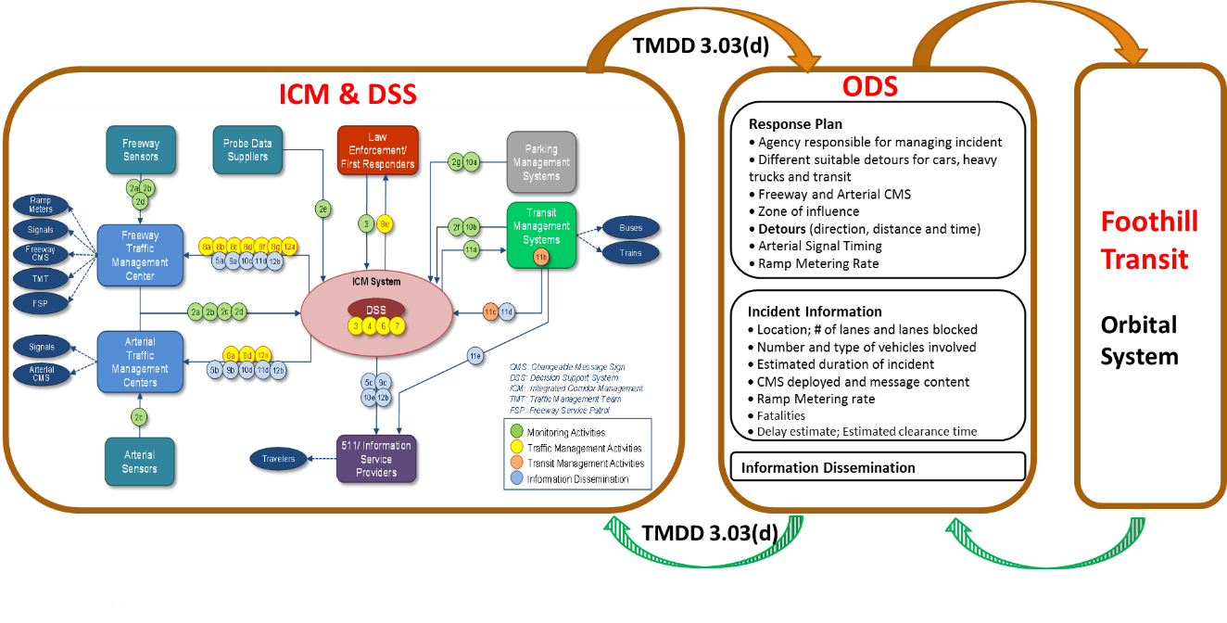

**Sub-tasks & Timeline for Task 2:**

|  |  |  |
| --- | --- | --- |
| Su-tasks | Description | Timeline |
| **Sub-task 1** | * Develop a database to receive real-time information (in TMDD format) from Caltrans’ ICM system. | 4 months |
| **Sub-task 2** | * Develop a system to convert the real-time messages from TMDD format to a format following the Foothill Transit’s Orbital Operation System. | 4 months |
| **Sub-task 3** | * Develop a website to visualize real-time information provided by Caltrans’ ICM and responses from Foothill Transit’s operation system. | 4 months |
| **Sub-task 4** | * Integrate the above system and database to form a ODS. * Testing ODS and improving ODS based on the feedback from both Caltrans District 7 and Foothill Transit. | Ongoing effort |

**Project Duration**

The project is set as 36-month.